West Hull Ladies
RRC

August Newsletter

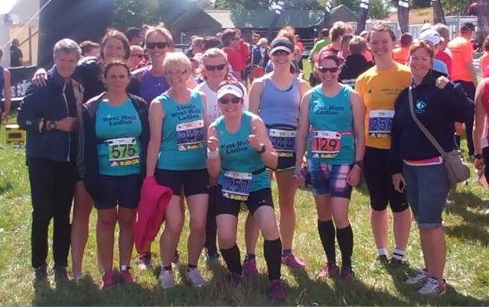

Thunder Run 2015

West Hull Ladies

WEST HULL LADIES COMMITTEE MEETING
Committee Meeting 3rd August 2015
Minutes
Present - Jill, Karen, Liz D, Jan, Maria, Anna, Sandra, Linda, Zoe, Amanda
- Apologies from Annette
- Minutes of previous meeting accepted as true record
- Matters arising - a) An email had gone out explaining Power of 10, Run England etc. b) Vests had been ordered. c) Event tent had been purchased. d) Yorkshire Vets. Action Jill to continue enquiries into this. e) Victoria Voase had been contacted and will complete form re name on West Hull Ladies bank account f) leaflets publishing Hull Marathon had been distributed by ladies at Thunder Run g) Karen to continue efforts to have name West Hull Ladies as the registered name and not West Hull Ladies RRC
- The Event tent had been a wonderful purchase and had been used at Thunder Run. It needed to be stored in dry conditions and Linda offered to do this.
- Jill stated that she had researched several 24hr races for 2016 and it would be good to know how many ladies would be interested in entering this type of event in 2016. This information was also useful as entries filled up very quickly. Action - Jill to send out email to Club members asking for expressions of interest.
- A discussion took place about the water station at Hull Marathon. A meeting for this was to be held on 20th August 2015. Action Amanda to send a reminder email week commencing 10th August.
- Jill said that 3 ladies at the present time had completed 100km runs in 24 hours and that it may be an idea for the Club to purchase vests for presentation to those having achieved this. Liz D also suggested maybe a badge. Further discussion needed to take this forward.
- a) Anna stated that we had 5 teams entered for the Hull Marathon. She would email the teams and let them discuss who would run which leg. Action Anna to contact all relay team members. b) Liz stated that she had obtained a quote for banner for the Club. It was £178 + VAT. The committee agreed to the purchase. Action Liz to order and contact Linda re payment. c) Zoe stated that it had been mentioned that it might be an idea to have the thresholds on a Friday reduced to once a fortnight instead of weekly. This needed further discussion with Amanda present but also mentioned that ladies could be flexible and those that wanted to run for mileage could do so. Members did often split into separate groups depending of training requirements for differing distances. Action Sandra to put on agenda at next meeting.

Meet a Member: Rachel Anderson

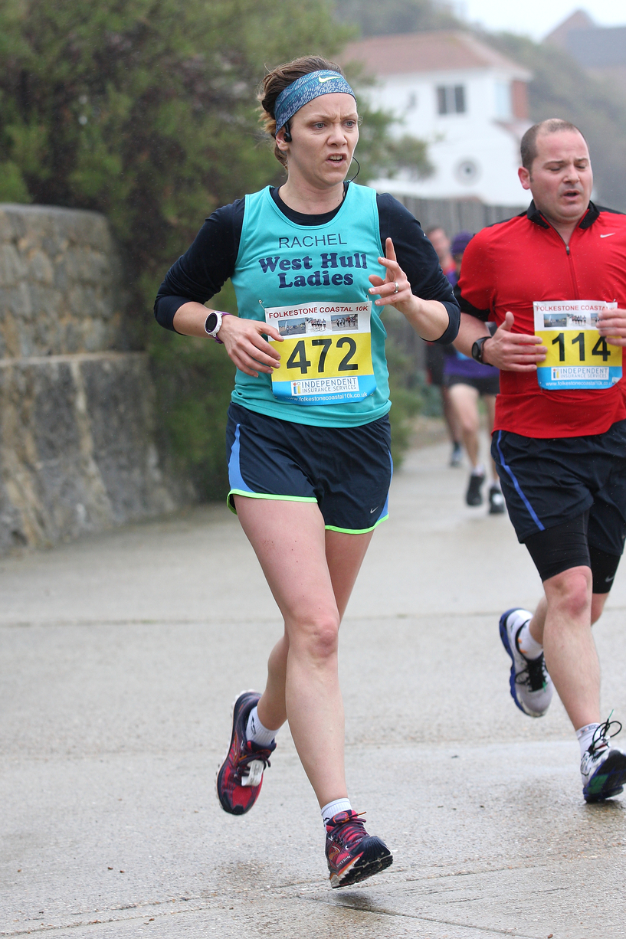

Age: 37

Member of WHL since: July 2014

What do you do when you’re not running?
I’m a senior lecturer in Psychology at the University of Hull. I also have two small children, Jacob (5) and Amelie (3). So… that’s about all I do away from running. In fact, it is only through having a very understanding husband that I actually find time to run at all!

How long have you been running?
I was a sprinter/hurdler and played hockey throughout my time at school and university. I had tried 800m at school and nearly died, so thought distance running wasn’t for me! I tentatively decided to try a couch to 5k programme in 2011, but was only just getting into it when I fell pregnant with my daughter. I took it up again in 2013 and ran sporadically. JT Hull 10K in 2014 was my first ever race and I joined WHL a few weeks later.

Why did you start running?
I’d always enjoyed sport, but with a full-time job and young family I was finding time to be rather limited. Running was something I could do when it suited me.

Favourite distance?
Tough one! I’d struggle to decide between 10K and half marathon at the moment. I like a bit of pace over 10K, but I feel a greater sense of achievement over the half marathon distance. I have a love/hate relationship with the marathon. I love the euphoria at the end, but I’m not so keen on the pain during miles 19-25!
Favourite bit of running kit
Those of you who know me will know I have a LOT of kit, which makes it hard to choose. I am a bit of a stats geek so I’d have to say my Garmin wins. I have every run since I started in 2011 recorded, with notes on how it went and what shoes I was wearing. Did I just admit that????

Any injuries?
I've had one major setback injury wise, which occurred just before Brighton marathon this year. I made it through the marathon, but I’m still working with a physio and podiatrist to fix issues with my left pelvis, knee and calf. All of these issues probably date back to my earlier days though, where I tore my left hamstring whilst hurdling and injured my pelvis playing hockey.

Running goals?
To get faster!! I grew up in a family of 7 children, with 5 brothers who liked to make everything into a competition. As a result I’m still quite competitive and like to push myself to see how far/fast I can go. At the moment I’m training for the Great Scottish Run in October, where I’m hoping to get a half marathon PB. Then I’ll be back into marathon training, hoping for an injury free Brighton 2016!

Proudest moment running related or otherwise
Running- Finishing Brighton marathon in April. I had seriously doubted I could run that far! Outside of running - my PhD graduation and seeing my children grow more spirited, independent and determined every day.

Best piece of advice you’ve received
Listen to your body - you have to learn to distinguish between different types of discomfort. If it just because you’re training hard then that’s ok - that’s the discomfort that will help you improve. If it hurts because your body is starting to break down then you have to stop! Rest is an important component of staying injury free.

Running alone or with friends?
Both. I quite like doing really long runs by myself, but a good chat with WHL ladies is always nice too.

What keeps you motivated?
The improvements I see in my fitness/times, and the desire to see exactly how much my body can do. Also, the fact that every time I bring a medal home my daughter assumes I won the race and thinks it is amazing :-)

Meet a Member: Jan Draper

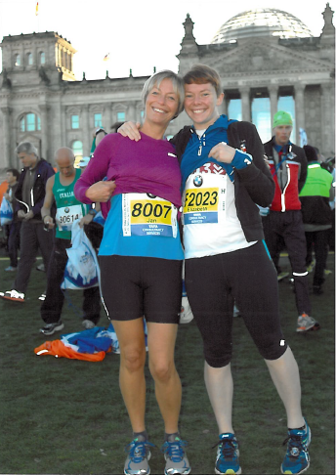
Age 53
Member of WHL since
September 2015
What do you do when you’re not running?
Well, quite a bit I guess! I work at the Open University and am based down in Milton Keynes. I work in the faculty of Health and Social Care and am a nurse academic. So I am away during the week, although I try to work from home Mondays and Fridays if I can.
I am mum to Liz (as you all know!) and Isaac and Tamar. They all live in Hull so it's great to have them close by. I live in South Cave and it’s lovely to be on the edge of the Yorkshire Wolds and to have lovely runs literally outside my back door! My other key hobby I guess is tennis, although I really only play during the summer season. Once again, it’s lovely having the tennis club within 5 minutes walking distance.

How long have you been running?
I started running in January 2004, principally as a strategy to lose weight. I have struggled with my weight for a lot of my adult life and apart from tennis, was not particularly sporty. So I decided to take up running at the age of 42! (for some unknown reason!). And I've loved it. Until joining WHL last year, I've been a solo runner and quite enjoyed the peace and solitude it brings. With a busy and stressful job, running first thing in the morning has been a great way of not only keeping fit but keeping things in perspective.
Why did you start running?
Well I guess I've already started to answer that question! Soon after starting running, my God daughter who had been battling Non- Hodgkin's Lymphoma died at the age of 18. So I decided that I wanted to do something in memory of Ruth. So I ran my first marathon in October 2004 (only 9 months after taking up running) in Dublin and raised money for Children with Leukaemia (now Children with Cancer UK). Not long after this, Liz decided that she too would like to take up running and it has been a family affair since then!
Favourite distance
I'm not sure that I have a favourite distance really. I have enjoyed doing all the distances from 5k park runs to 10ks, half marathons and full marathons. I've done about 15 marathons now and Liz and I have often used it as an excuse for a city break somewhere! This includes places like Paris, Amsterdam, Berlin and Barcelona.

Favourite bit of running kit
I love the jazzy gear you can get- TKMax is great for this! But I guess I would say that there are two things I would consider essential. One is a good- fitting bra- I run in Shock Absorbers- and the other is toe socks (Injinji is a good make). Toe socks have been a wonderful discovery and I've not had a blister since I started wearing them.
Any injuries?
I have been very fortunate in terms of injuries. I had a prolapsed disc a couple of years ago, which resulted from me filing my feet ready to run the Barcelona marathon! Yes you read that correctly! (and by the way, I still ran the marathon!). Most recently I have been nursing low grade Plantar Fascliitis which was seriously aggravated, during the Champagne League. So at the moment I'm resting it and hoping that treatment from Jamie will get me sorted!

Running goals?
I'd love to do a sub- 4 hour marathon. My PB is 4:01 but that was a few years ago. The healthy mother- daughter rivalry might help boost me on!
Proudest moment running related or otherwise
This would have to be completing my first marathon (Dublin 4.20) and then getting so close to sub-4 in Amsterdam. Elsewhere in life its just seeing all my three children grow up and become such wonderful adults!

Best piece of advice you’ve received
Get to know your running body, experiment with fuelling and hydration strategies and then once you've found something that works, stick to it and don't change. And particularly don't do anything on race day that you've not previously practised.

Running alone or with friends?
As I have already mentioned, for the last ten years I've most often run alone and so I wasn't quite sure what to expect in joining WHL. But it has been one of the best things I have ever done! You are all so welcoming and encouraging and I have made a whole new set of friends! I can't imagine life now without you all!

What keeps you motivated?
In short, three things: keeping weight down; keeping fit; and keeping ahead of Liz!

Burton Constable Ten K Trail: Anna

I was looking forward to this run, as it marked the start of the blissful 7 week holiday. My sister- in- law used to work in the café here, so I have spent many happy afternoons drinking tea in this pretty courtyard. This visit however, things were bit more active!
I had not slept well- had funny dreams about the event. Not collecting the number in time, eating tuna and crisps as we were about to start (?!), everyone getting up late etc. So I was relieved to simply to be there on time wearing my number!
We had fun watching Thomas's race first- and there were some talented runners taking part. It was a decent distance off road for the under 16s and wow- some of them flew to the finish.
I then found the club, and there were plenty of us- a great turn out. We huddled for some photos, just about missing all the rain that had been forecast, and were ready to set off .This was a nice small race, so it was quite good fun waiting to start- lots of chatting rather than being jostled about.
I started off with the usual enthusiasm, and had Sandra's advice in my ears- "if you feel like running fast- just do!" So I did. I had a little group that I wanted to keep up with, and managed OK. The first lap was timed at 32min- so I was pleased. This is when I realised how well the junior runners had done- I take my hat off to them- I had covered only just over the distance that they covered- wow. Long way for little legs.
The second lap I found trickier. The unevenness seemed frustrating and the runners ahead looked really far away! Again- I had a group to stay with who suited my pace- we all ran in a line. I even started a little mantra- "Blue top, pink top, orange top and me". That helped for a bit, as did counting. Never done this before, but it was really helpful. I estimated where I would be by 100, and had a go at getting there. Distracting and motivating.
My least favourite part was running through the caravan park- as the surface changed and undulated a lot- not easy.
As my family came too for the day I had lots of shouts of support from them- that was a boost. The course was well planned for spectators- there were a surprising number of places for people to support and watch which was nice. And the sheep were very well behaved- on the second lap they were running across the path- but stopped for each runner! They knew their green cross code!
This was a lovely setting for a ten k- and I hope that they organise it again next year.

Burton Constable Ten K Trail: Andrea
After my experience of Walkington the week before, I was feeling – if not confident, then unconcerned – about Burton Constable 10k. This was a new trail 10k and thanks to WHL I now enjoy trail running. The weather was as different from the week before as it could be – cool, blustery and rainy. I picked Jane up (early of course) and we made our way across Hull to the beautiful grounds of Burton Constable Hall.
Once again the race was really well supported by WHLs and we had the customary team photo at the front of the house. This wasn’t a chip timed race, so we all gathered at the start then we were off.
I’m not quite sure what happened to me in this race, but I really struggled. It’s almost like the more confident and comfortable I feel before a race, then the worse I perform. Fortunately for me I had the wonderful company of Kristine to keep me going. My goodness that woman has some stamina! The race was run over 2 laps of the grounds, and on the second lap we encountered some rather excited sheep who seemed to have heard about the lovely tshirt at the end and wanted to join in. Kristine doubled back to clear the way for the runners behind us, then caught me up again singing ‘high on a hill stood a lonely goatherd’ much to the bemusement and fear of the nearest marshal. I kept trying to persuade Kristine to run on and leave me to my miserable plodding, but she would not have it, and I’m very glad she didn’t!

Finally, at long last we rounded the last corner and crossed the finish line. My time was 1:16:27. Definitely not my best 10k time, and I can’t honestly say I enjoyed it, but I probably would do it again (oddly enough) now I know what to expect. The route was nice and the company during the run was brilliant – thank you so much Kristine for putting up with my whinging and spurring me on.

York Jane Tomlinson Ten K : Liz

On Sunday 2nd of August me and Chris lined up for the Jane Tomlinson York 10k. This was the last of our Scenic Cities season ticket after Lincoln in March and Hull in June. Always looking for a bargain I had booked these soon after doing the Hull one, (my first 10k), last year. They haven't got their new ones out yet, but this year you more or less got three for the price of two and you get an extra memento in the form of a scenic cities t shirt.
I would say that York is probably the most popular of the three and that if you are going to do it, or any of them you have to set off early. We also parked at Fulford and walked over the Millenium bridge as normally there is a traffic issue, indeed this is true of all the JT ones we have done. We arrived at the Event Village with plenty of time but then spent an inevitable 30 mins in the toilet queue, why oh why are there never enough toilets? They did sensibly have a men only area which probably helped the situation a bit. We then got in the race pens where they have your prospective times. Optimistically, (but mindful of JIll's advice for a good time), I joined the sub 60 pen, it was really crowded but I did spot Fatma about 20 metres ahead, however I could not move from where I was. They also have a bit of a warm up before the race, I tend to just stick to marching on the spot, I thought that the lady doing the warm up was pushing it a bit when she tried to get everyone to do star jumps, I mean someone could have lost an eye if we'd tried that! The race went off ten minutes late which was an improvement on last year. There is always a few minutes before you finally get moving and as I did get going I heard first and then spotted Jill and Zoe who were supporting Micheal, (West Hull Laddie) and they gave me a special shout!
The course itself I find quite hard because although it's not that hilly, it never seems to be on a flat either, (if that makes sense). Having said that York is such beautiful city and the support is epic. I really loved running near the Minster area which is about half way and one of the church's bells were ringing. I did have a bit of an issue when I was nearly taken out by a Japanese tourist along with pilot case, when trying to grab a water bottle at the drinks station, clearly I was moving too fast and he didn't see me! After running round the Minster Area you then head back along the other side of the River back to the Racecourse, annoyingly, they have had to put two extra loops in which are a killer as you are heading for the finish. I did find it the toughest of the three scenic cities and managed a time of 67mins 28 secs, I was hoping for around 65mins and so was disappointed, but cheered up when I looked at last year's time which had been 74 mins exactly. Fatma also got a PB which was an excellent 59.41 and Chris did just under 50mins and Michael did 50:32.

As a postscript I managed to beat Ronnie the Leeds Rhinos mascot, I burned him off at the Millenium Bridge hopefully putting a marker down for the Challenge Cup final!

Thunder run: Linda

Friday morning finally arrived for our trip to TR24. Jill, Zoe, Kristine, Liz and Jan came to my house, loaded up and we were off. Rachel, Jane, Andrea and Maria following on later in the day. Debs was due to arrive on Saturday.
Arrived around 11.20 and found a great spot to pitch our tents which had to be done quickly as it had started to rain! What is it with WHL and rain this year? We all mucked in and before long we had up the event tent, Jill’s huge fancy tent plus Jill’s second tent which was for me, Jan and Debs. Along came Andrea and we soon had her big tent up too. By the way ladies the event tent is awesome it housed all our food, cooking equipment, tables and chairs and kept us dry which was very important!

Then we registered, finally this ‘thing’ called Thunder Run which we seem to have been preparing for for ages is finally real! We picked up our numbers and our lovely purple/blue t’shirts and was given shower gel and deodorant as an extra! Clearly they were expecting some body odour at some point over the weekend!
Finally it was time for our last sleep before the event, by now the rain was hammering down and there was music/partying going on at the start area in a fancy bus which went on until the early hours. I’m sure I got some sleep though even if I was cold all night. Next time we do this I must remember to wait until summer actually arrives!

Up at 7am, breakfasted and washed up, now the long wait until 12noon. Jan decided to do a recce for us so off she went. By now the sun (yes sun), had come out so we could start drying off the tents and our shoes and socks. Jan came back with reports of any hazards we had to watch out for.

So I’m going to share with you our little diary as the hours ticked by, as doing this in pairs you don’t see your partner for a proper chat only a quick hand over.

12:00-13:06 Rachel Lap 1 1:06 (Rachel to Linda) Hope you enjoyed the mud! My legs are covered already! Rest up ready for the next one.

13:06-14:12 Linda Lap 2 1:06 (Linda to Rachel) Not bad but I think I need to slow down! That mud is very slippery.

14:12-15:15 Rachel Lap 3 1:03 (Rachel to Linda) Sorry! That lap was faster! I promise to slow down.

15:15-16:23 Linda Lap 4 1:08 (Linda to Rachel) Not so muddy this time and a bit slower – my toes are sore! Slow down!

16:23-17:31 Rachel Lap 5 1:08 (Rachel to Linda) I had the most horrid stitch all the way round that lap and had to walk downhill! Hoping the next one will be better, but definitely slower. I’m feeling the heat and my right knee is sore. Hope your toes are ok.

17:31-18:40 Linda Lap 6 1:09 (Linda to Rachel) Didn’t find that too bad but my toes are sore. Tim from City of Hull helped me to the finish or I would have walked more. I am tired. Are you?

18:40-19:55 Rachel Lap 7 1:15 (Rachel to Linda) I’m exhausted! I had bad stomach cramps on that lap and it was so tough. I met Zoe at 8k and she kept me going to the end. I’m expecting to walk a bit more the next lap. What on earth were we thinking?!

19:55-21:07 Linda Lap 8 1:12 (Linda to Rachel) I’m exhausted and my quads hurt like hell! The next lap will be much slower as I will be walking in the woods so I don’t trip in the dark!!

21:07-22:26 Rachel Lap 9 1:19 (Rachel to Linda) Sorry! I’m getting slower and slower. I’ve changed my shoes to see if that helps my knee, but I’ll be walking a lot of it. Probably 1:20-1:30 I expect, sorry.

22:26-23:51 Linda Lap 10 1:25 (Linda to Rachel) Don’t be sorry this is tough and I hurt too! I’m definitely taking it very steady through the darkness. I took 1hr25mins!!! Sorry. If you need a break we can this is endurance and stamina but we need not to be injured. You’re awesome.

23:51-1:29 Rachel Lap 11 1:37 (Rachel to Linda) I’m in Bed! I’m broken!

1:29:3:10 Linda Lap 12 1:40 (Linda to Rachel) Sleep – yes please! I feel drunk (and I haven’t touched a drop for years)! We will not carry on – you don’t need to injure yourself further. Thank you for being my partner you are amazing.
(Rachel to Linda) 37.2 miles each. We are superstars! It would have been nice to go further but thank you for making me be sensible. I hope you’re happy with how far we’ve gone. It was an amazing experience and you were an inspiring partner. Thank you. R xx

Our race ended at 3.10am on Sunday morning, although we are both kicking ourselves today for not trying to manage at least another lap each. But we are WHL and although we are tough we have to be sensible, Rachel runs long distances and if she really injured her knee badly and her ITB then it would take much longer to mend. We had a ball, Liz and Jill did fantastic in their pairs (but I’m sure they will share with you their diary too) and our team of five were absolutely fantastic and watching Maria bring home the team on the last lap in the pouring rain was very emotional.

This weekend wouldn’t have been so well organised if it hadn’t been for our very own WHL Mummy the wonderful Jan Draper who kept us going, kept us fed and watered and generally made sure we were ok. She is our STAR.

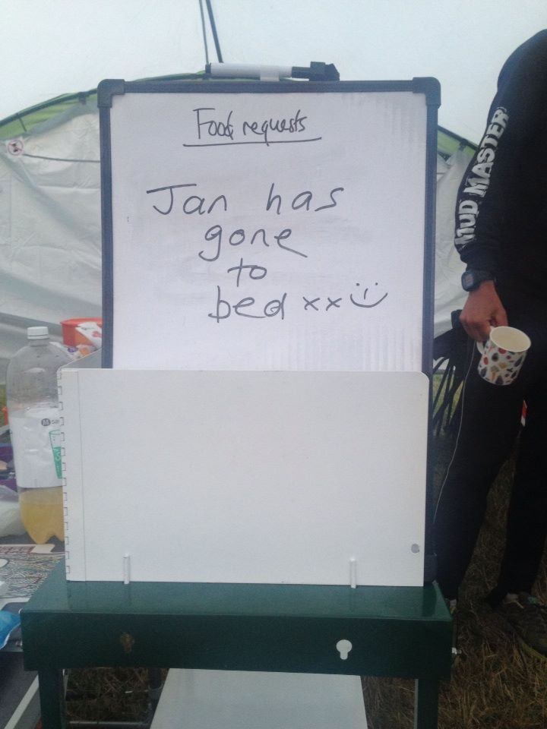

Thunder Run 24: Rachel A
I originally signed up to TR24 as part of the team of 5. However, when Jan got injured with a couple of weeks to go I volunteered to pair up with Linda to be ‘Barking Bonkers’. Had I been planning to be part of a pair then I’d probably have done a bit more preparation, but you live and learn! After each lap I noted my thoughts (as I do for every run I complete). I’ve decided to share these as my race report; they give a fair reflection of the highs and lows of the event.
Lap 1 (1:06) – I lead off the partnership at midday. We were all really excited to get going. The sun was out for this first lap and it felt good. The route was muddy and slippy because of all the rain the day before. I tried to take it as slow as I could, but it was tough to keep the pace down. I came in quicker than planned - I hope Linda isn't too cross!

Lap 2 (1:03) - This lap was easier because the mud was starting to dry out and the volume of runners on the course had spread out. I really enjoyed this lap. It’s a tough course, so many hills! I really love the bit where you run across the field on top of the hill and can see all the runners below – that was awesome! Oops! I ran that lap a bit quicker – Linda will be telling me to SLOW DOWN!!

Lap 3 (1:08) – This lap was SO hot! I’m starting to struggle with fuelling now – running every hour is hard. There isn’t much time in between to change, stretch and fuel properly. I’ve been trying to eat proper food, but I’m not sure I’m having time to digest it properly. I had a stitch all the way around this lap. It made running downhill really uncomfortable, and I had to walk a few of the downhill sections as a result.

Lap 4 (1:14) - I thought the stitch on the last lap was tough, but severe stomach cramps kicked in on this lap. It was really hard because each time they came on I had to stop to walk. My right knee is also starting to niggle. This is a real surprise as I’ve never had any problems with this leg. My left leg, which has been the problem in the past, seems fine. There were a couple of points where I started to feel despondent on this lap and towards the end was struggling a bit. Luckily, I bumped into Zoe at 8.5K and she kept me going through the final bit of this lap. The next lap will take me further than I've ever gone before - it will also require the head torch! Its 8pm and I'm starting to wonder how on earth I'll keep this going for another 16 hours :-(
Lap 5 – (1:19) - This lap broke me. The stomach cramps haven’t gone, if anything they are getting worse and my right knee is now really painful. It started to get dark as I ran and I will admit that I cried around 7K. I just wanted to get back to camp and lie down. I was sobbing when I handed the wristband over to Linda and on Jan’s shoulder when I got back to camp. This is so tough. I'm worried that I'm going to let Linda down; I can't see how I can keep going all through the night. I'm already exhausted and my knee seems to be really struggling with the downhill sections of the course now.

Lap 6 – (1:39) – I set off on this lap at 23:52. I told Linda on setting off that I would have to walk most of this one; partly because of the stomach cramps, but mainly because my knee is so sore. Also, in the dark, the tree roots through the woods are treacherous. I think 90% of this lap was speed walking with a bit of gentle jogging. It seemed endless. I was fantasizing about a warm bed and I hoped that Linda would suggest taking a break when I got back. She did! I sobbed and hugged her - the sweetest words I've heard for a long time! I was semi-delirious at this point. I crawled into bed in full running kit, removing only my head torch, and fell asleep almost instantly! Linda did one more lap, nearly fell into a bush, and went to bed at 3am. I woke at 5:15 and Linda and I assessed the situation - my knee was still sore and I self-diagnosed it as my ITB. I wasn't sure I could RUN any more laps. I could walk them, but was that the point of TR24 and would I do more damage? Zoe decided to call it a day with similar knee pain and warned me about how difficult ITB problems were to deal with if you didn't heed the warning signs. So, Jan, Andrea, and Linda talked me into the sensible decision of stopping at this point.

To sum up, in 15 hours we ran 120K. That’s 37.2 miles EACH!!! That's a LOT! We each ran further than we’d ever run before. We drove ourselves into near delirium. However, I feel like I've let Linda down, as I know we both really wanted to go further. Its one thing to disappoint yourself, but it is really hard when you feel you've let your teammate down. But, I’ve gained valuable lessons from this experience and, most importantly, I’ve made a great friend in Linda. Sharing an experience like TR24 with some really builds a bond! and I intend to come back stronger as I have unfinished business with TR24 now - I want to go back as a pair next year and make sure that one of us is running across that line at midday to finish the 24 hours - that's how it was meant to be! It will require more careful planning of food and sleep breaks. I now know that I cannot run for 24 hours with only hour breaks and no sleep. I need time for food to digest and I get delirious after 15 hours being on the go! However, I'm certain that, next year, we'll both still be running (albeit rather slowly) after 24 hours :-)

Thunder Run – Jane

I'm writing this at 3.30am in morning full of cold/hayfever so bear with me.
I was a little apprehensive when Andrea pulled up outside my house to pick me up, however that soon went after we bundled Rachael A into the car and were merrily chatting as we drove along.
When we arrived the others had already erected the gazebo and their tent so we had much work to do before the rain started. We organised our little kitchen then started on the tent. This was all new to me so I followed instruction from captain Andrea and the others. Before long it was up and we were sorted.
Not long after the rain started and it hammered it down from what I recall, more or less the rest of the day. It subsided for a time as myself and Andrea went exploring and I bought a few items with the spending money I had very kindly been given by my lovely hub!
When we arrived back at the tent sum COH lads had popped in to welcome us, and a cuppa. We had saved them a camping spot. Maria arrived, followed by the lovely Debs shortly after. Our team was now complete.
The time had gone pretty quick so we decided to have our tea. A yummy pasta bolognaise made by Jill, also on offer a lentil bake I believe made by Zoe as we as enough other food to feed an army. Not long after we all turned it for the night awaiting our plight for the next 24 hours.
The bar was still buzzing as we all hit the hay. I could hear the hum of the music over the rain as I tried to sleep. It was bitterly cold and my sleeping mat wasn't much relief to my back on the hard ground. (Last time camping I was 15. Definitely feeling my age now, regarding sleeping on a hard floor). When I did finally drift off I was awoken with the urge to go to the toilet, argggh. When I finally managed to find my way out of the tent, without waking Maria, Andrea and Rachael A, (who later told me she was still awake anyhow). I put on my flip flops (yes the grass was wet and cold, but the rain had stopped) turned on my electric lantern and set off in the dark to the nearest portaloo. (Lucky for us they weren't far). When I finally snuggled back down in my sleeping bag and nodded off I believe my time asleep that night to be 3 hours only.
When I got up the next day, (around 6.30am) the sun was trying to come out and others were already enjoying their morning caffeine fix. I munched on a banana followed by a pot of porridge for breakfast while we all chatted about the challenge ahead.
Jan had decided that she would Recce the course for us so we waited eagerly for her return and the feedback." Muddy in places and quite treacherous, followed with Jane be careful of that ankle. Remember to take it steady ladies was also what she came back with".
We had quite a lot of time to get organised and relax before the start so after we had washed up etc. we sat outside in the sun chatting merrily. COH lads team of 5, arrived to wish us luck and also to indulge in Jan's hospitality. cups of tea and homemade flapjack.😋. We all refuelled for lunch (Gluten free rice cakes with cashew butter and chopped banana followed by a delicious piece of flapjack, for me anyhow) As we relaxed Jill decided to interview each of us before the big event. We all took it in turns to take centre stage. What a laugh! These ladies are great!

The time ticked on. After preparations had been made by the pairs and our Solo Zoe, and we had all got changed into our running attire we all made our way to the start to see off Zoe, Kristine from our team of 5, and Rachael A and I believe Liz from the pairs. The atmosphere was buzzing as everyone waited in participation for the start to commence.
A huge cheer went up as we were away, with chanting and applause from everywhere. We found a space at the railings and cheered our ladies through before heading back to camp.
Times had been calculated by Andrea and co estimating how long each lap would take so the next team member knew approximately what time to set off for the holding area. Before long it was time for our next lady's to enter the pen for the changeover. Kristine, and Liz arrived back at camp informing us of the conditions, experience etc. I was next up. Andrea saw me off with shouts of "good luck, be careful". I set off through the site directed by the brilliant marshals as I passed them. There were lots of ups and downs. Including treacherous climbs through woods and slippery descents in the mud. What beautiful scenery though and a lovely course. As I approached the finish I saw Andrea eagerly waiting her turn so I slapped the yellow baton on her wrist and she was off.
When I arrived back at camp, I was happily greeted by the others. After I had refuelled and completely changed my gear, settled down to wait for the ladies coming back from their lap. They came and went refuelling and stretching out on the grass afterwards. The foam rollers were also in use. After my second lap my Mummy WHL Tigress Jan, very kindly gave me a calf massage to ease the tightness caused by the gruelling off road conditions. The light was starting to fade as I set off for lap 3, and over the tannoy they announced that all runners going out on the course after 8pm must wear a head torch. That was me so with headgear attached I waited my turn. Maria came storming round the corner and I was off again. The ground had nearly completely dried out now so running conditions were easier. I could also hear the other runners approaching easier, like wildebeasts on the Serengeti before they stormed past me with a shout of "coming on the right". I didn't use my torch until I entered the woods. It shone brilliantly lighting up my path.

It was late when I finished this lap, others had gone to bed. I had a drink sum food then made my way to bed.
I was awoken at 2am (bed at 11ish so 2 hrs sleep) by Kristine, to get prepared for my next lap. I dragged myself up and made my way to the gazebo to wait before heading out to the holding area lead by the beam of my head torch. It seemed like an age of watching lights approaching the line before Maria came into view. She had hurt her leg and so had found it tough. I was relieved to see that she was ok and nothing had happened to her.

I set off into the night guided by the beam of my head torch, I could see the flames of the campfires made by the night marshals to keep warm and be seen. I ran steadily being extra cautious on the steep inclines. Through the woods the roots and tree stumps were hard going in daylight so as the others had advised me I walked through this part carefully stepping over each root. After the last climb up through into the clearing, I could see that it was nearly daylight already and could turn off my head torch! Andrea was waiting for the changeover and greeted me with a relieved smile as I handed over the baton. In camp Jan was up and made me a lovely cuppa before others started to stir. She ushered me to go and get changed and freshen up. She was an amazing member of the team. Seeing to all our different diet requirements which she wrote on a white board to prepare for when that particular food was required. Making tea, and being fab support mentally!.
Debs had decided to run two laps on the trot as she wanted to do 5 laps this year so we reorganised our schedule to Kristine, me and then Maria doing our last and final lap. This lap I found the hardest as my tired legs and lack of sleep had taken its toll it had also started to rain again. I urged my body up the hills and trotted happily down them until I finally saw that finish line. When I passed the baton to Maria I was overwhelmed, I'd done it 40k in 24 hours! I'd achieved my goal and was elated but shattered. Tents were being packed away when I arrived back so quickly got changed and buckled into helping. The rain was really coming down now so we were all pretty soaked. Rachael's hub arrived with the kids and gave us a hand too while they happily played together.
We all ventured down to the finish line to cheer Maria in on her final lap. What a trooper she is. It was an emotional event for us all as we were physically and mentally exhausted.
Having so undergone a huge challenge and an amazing experience. Zoe had done 10 laps, the pairs had done 6 laps and in our team Debs had done 5 laps myself, Maria and Kristine 4, and Andrea 3 (only as we had run out of time, so had a sleep as she had a long drive ahead of her).
What an amazing experience had by all. Brilliant company, fab course and something I will never forget until I do it next year!!😆
Thankyou ladies for all your help support, friendship and encouragement throughout this amazing weekend adventure we shared together. Thankyou for allowing me to share this wonderful but mad experience with you all.
Till next time.......

Thunder Run: Jill

At the end of July 2015, 11 West Hull Ladies went to Catton Park in Derbyshire to compete in the Adidas TR24 Thunder run, a 24 hour run for individuals and teams. The run up to the event had not been particularly smooth with Jan having to drop out of the pairs event with Linda, due to having plantar fasciitis, and also Trish being unable to crew for us due to illness. Nonetheless the intrepid runners turned up early on the Friday morning to pitch tents and set up camp in the pouring rain! Jan agreed to crew us which was brilliant, and Rachel A decided to swap from the team of five ‘5 go mad in Derbyshire’, to the pairs with Linda (Team: Barking Bonkers). To fill the void in the five, Debs Butler joined the five, instead of being part of the crew. The five also included team captain Andrea, Jane, Maria and Kristine, and I was also in a pair with Liz (Team: Racing to the finish Wine!). We also had Zoe going Solo (?!??!). The rain was awful on Friday, so it was a good thing that we had decided to invest in an events tent, which was an absolute godsend as we could relax together as well as cook under it! The ladies showed excellent tent erecting skills, with Liz and Zoe particularly taking the lead, and we had enough food to feed half the campsite! We were visited by various teams from City of Hull AC, who snaffled flapjack and drinks…who were also suffering from event tent envy!
By Saturday morning, the sun was out, which was a relief. Debs also arrived with kit that she had taken home after Endure 24. Jan went out to recce the course and reported that it was very muddy and slippery, which was a bit of a worry. Ultimately, I suspect that other team members will write a piece about their experiences, so from this point, I will talk about my experiences of doing a pair with Liz. I was a bit nervous to be paired with Liz as she is developing into a strong ultra-marathon runner, and I felt a bit daunted, and worried about letting her down. Liz started off running a strong lap of the 10k course of just over 70 minutes, running with Solo Zoe. This is really good as the course is hilly and challenging, even without the mud that was like gloopy toffee at various parts. I took over from her and ran with Zoe. Debs joined up to do an interview with us both on the run, which was hilarious. Unsurprisingly, I managed to fall down in the mud. Luckily the mud was so soft, so I was not injured, but my trainers were about twice the weight and size due to the accumulated mud on them! Both my first and second laps were done in around 70 minutes, which I was pleased with, and fortunately the course became less muddy, so I was able to put my road trainers on for lap three. I was really relieved about this, because my trail trainers are not very flexible and were not particularly comfortable on my feet. Lap three was generally okay, although I was starting to worry how many laps I would actually manage. By the 3k mark on lap four, I actually had a bit of a meltdown. I think it was because I was tired, my feet were hurting, and I was really worried about letting Liz down, as I know she was wanting to try and do 10 laps. Running and having a meltdown is not the best policy. My tears were really salty and burned my eyes, and I had to give myself a serious telling off…telling myself to get on with it and stop being daft. Anyway, I pulled myself together, and by around 7k, encouragement by Richie from City of Hull as he whizzed by me, made me feel much better and raring to go. On passing over to Liz, she looked in excellent form. What I haven’t said so far is that it is really important to make sure that you keep well hydrated and eat reasonably, which is sometimes quite hard in these situations. This is where Jan was amazing, as she really supported us with food, drink and general encouragement. After lap 2 I had suffered cramp in my quads when I had tried to change my kit. This was really tricky as I was sat on the floor, in my tent, half undressed, unable to move as every time I tried to bend my legs they cramped, so I really needed four hands, two to put pressure on my cramping muscles, and two to get dressed! I almost had to shout for help, but fortunately it did go off and I was able to get sorted, before I made an idiot of myself. Jan’s jam sandwiches made me feel lots better, and by lap five, I was happy about running in the dark. This was one of my favourite laps, as I spent the whole time, chatting with a nice woman from Manchester called Rachel. When I eventually got back to the changeover point, I was trying to be positive and get my head around going out again after Liz had been out. However Liz was concerned that her stomach was feeling bad, and suggested that it might be a good idea to have a bit of a break, to try and sort this out. I have to say that I nearly kissed her I was so relieved, as I was really tired and wanted to sleep so we went back to the campsite and went to bed. We did manage a few hours’ sleep which was great, and also it made it much better for me in terms of driving back home on the Sunday afternoon. By the time we got up, it was light again, and we decided that we would do another couple of laps each. This would give us around 43 miles each, which was further than either of us had every run before! The first lap for me after the break, was fine, but it absolutely chucked down with rain for the second lap that I did, which was a bit grim! I had also been surprised about how cold it had been overnight for the middle of July (Summer? Humph!). Whilst I feel that I have unfinished business with the Thunder run, we did have a great time together as a group of runners, and had some good laughs. If you want to see some of the good times that we had, you might want to look at our Thunder run film. https://www.youtube.com/watch?v=fCOB3ZO2tlU&feature=youtu.be

Thunder Run: Andrea

I've found it difficult to know where to start writing about TR24 without going on for pages and pages, and as other WHL will be writing their own recollections of the weekend I've decided to concentrate on the parts which stood out for me.

1. The atmosphere at the mass start at 12 noon on the Saturday was amazing. Everyone setting off at the same time . Feeling a part of something really special.
2 My first lap. The anticipation of waiting for Jane who I was taking over from, wondering how I would get on. Then running my first lap, thoroughly enjoying it and being delighted with my time. Running in to the finish and seeing Debs waving and shouting my name as I passed the wrist band over to her.
3. Lap 2. In the dark. Being absolutely flipping terrified of the prospect of doing it, worried about getting lost, falling over. ...but being inspired by the wonderful text I'd received from my daughter and the thought of the money I was hoping to raise for Breast Cancer Care (almost £700 at the last count) The relief and huge sense of achievement at completing it. And not getting lost or falling over.
4. My third (and final) lap and not being as tired as I thought I would be. Inspired by chatting to another couple of runners on the way round who were walking to complete their laps despite injury.
5. The camaraderie of all the runners of all abilities, some running solo intending to run 10,11,12 or more laps, some in teams of 8 running 1 or 2 laps but everyone taking part in the same event.
6. My disappointment on realising that due to time, lack of sleep and the drive home that lap 3 had to be my last when I'd set my sights on 4. And being determined not to let that spoil my sense of achievement. (I haven't!)
7. Watching and cheering Maria finish the final lap for our team and hearing our team get a mention over the tannoy.
8. The friendship and support from all of the WHL and being so proud of my team Jane, Maria, Kristine and Debs, the pairs Rachel and Linda and Liz and Jill and solo Zoe and for the wonderful support provided by Jan.
9. The t-shirt and medal which I would wear every day if I could and the realisation that I really can do more than I ever thought I could. And if I can do it..... ANYONE can.

Thunder Run: Zoe

Well, when I decided to enter Thunder Run again this year I hoped the experience would be as positive and as ‘fun’ as last year. As we travelled to Catton Park the clouds got darker and the rain came down, oh joy! The weather was obviously not going to be as lovely as the previous year and I began to think of the mud bath at the event in 2013. We found a nice camping spot in the corner of the solo area and constructed our rather impressive event village. I gradually got more nervous during the evening and went to bed apprehensive, hoping that I would sleep more than the 2.5hrs that I got at Endure24. Waking up in the morning, I was glad realising that I had managed to get a good night’s sleep and also that the sun had come out and it was looking like it was going to be a nice day. I was feeling very happy and quite chilled until mum decided to put the camera in my face (note for next year – hide the camera). At 11:30 we made our way to the briefing, and yes mum still had the camera! I just wanted to get going but that half hour seemed to last forever. Liz and I stood on the start line with some of the guys from City of Hull waiting for the race to start.

Setting off on that first lap was amazing, I ran with Liz and the crowd were amazing as we ran through the campsite. There was quite a lot of mud on the first part of the lap and people were sliding everywhere and falling over! I enjoyed this lap but knew that I would have to do another lap before I had a break. I picked mum up at the changeover point and ran with her for my second lap. It is no surprise that mum managed to fall over in the mud within the first 2 km (what a Wally!). Then Debs joined us to do some filming on the route. This lap was a little faster as there were less queues at the bottlenecks and I was ahead of my predicted times. Returning to the campsite I was looked after by ‘Mummy Jan’ who made me some lunch and a cup of tea.

Laps 3 and 4 were more difficult and I realised that I needed to take more food with me to eat during my laps. It was also lonely as I was no longer running with the pairs. The sun and breeze had started to dry the route which helped as I was no longer slipping and sliding and my shoes felt much lighter. Coming out of the wood at 8 km there was an amazing view over the surrounding countryside which made me realise how lucky I was to be running on such a beautiful day.
My next two laps went really well and I felt good. I was also still ahead of time coming in for my next break at about 9pm. I was struggling to eat by this point but still feeling ok and looking forward to my night runs. The temperature had dropped rapidly and I could see my breath in the light of my head torch. Not what I expected for a July evening!
Running in the dark was brilliant; it is always my favourite bit….well, until about midnight when I start to wonder what the hell I am doing! By this point I had slowed down and ended up behind time. Mainly because I started chatting to other solos! It is nice to chat and to get to know other people’s running experiences and reasons for challenging themselves and it kept me going. I returned to the camp after laps 7 and 8 at 1:20 am….a time which I really shouldn’t be awake let alone running! I soon got very cold and was shivering whilst trying to make myself a jam sandwich. It was so much harder to do this as ‘Mummy Jan’ had gone to bed ☹. Getting changed also took much longer at this time in the morning and I just wanted to lie down and fall asleep. By this point I was still on track to get 15 laps in if I kept up the pace.

Going out on lap 9 I soon warmed up and seemed to be moving quite well, once again I got chatting to different people and, even though I was tired I felt like I would be able to keep going. Unfortunately, at half way I began to feel a niggle in my left knee which I have previously experienced at the London Marathon which stopped me running for several weeks. I was annoyed at this but decided that I would be better walking the rest of the lap so as not to make it worse. By the time I finished the lap the sun was coming up and I was very cold. I decided that I wanted to do at least 1 more lap so as to equal my distance from last year of 100km. I went back to the tent and dragged 2 coats out of my case then started lap 10. This was by far my slowest lap as I walked the whole thing and chatted most of the way round which kept me going. When I finished the lap I was cold and decided to stop before the rain came. I had a shower and a nap then watched and waited for the other West Hull Ladies to come in. It was nice to see everyone as I had only seen 3 of them on the way round. It was lovely seeing the teams coming over the line, even though it was raining AGAIN!
Overall it was a really good weekend despite the rain. The camping was fun with a great group of people and I can’t wait for next year!

2015 RACE DIARY
http://westhullladies.org.uk/races.htm

Free 5K time trial every Saturday 9am: Hull Parkrun or Peter Pan Parkrun Humber Bridge parkrun

August 2015
 | 2nd/09:30 | Jane Tomlinson York 10K | £25.82 UKA/£27.96 | Online entries only | online entry
 | 16th/11:00 | Escrick 10K | £12 UKA/£14 | Entry form | online entry (+£1.70)
 | 23rd/10:00 | Major Stone Half Marathon | £18.20 UKA/£20.20 | Online entries only | online entry
 | 30th/09:00 | Jim Dingwall 10K | £13 UKA/£15 | Online entries only | online entry
September 2015
 | 13th/09:00 | Hull Marathon | £35 UKA/£37 | Online entries only | online entry

Please remember to double check dates, times and entry fees with the official website or the entry form.

Keep checking the website for new races and updates:

NOTE: Club Vests must be worn at any races you enter
under the West Hull Ladies running club name.

West Hull Ladies Road Running Club
Kit Order Form

FORENAME ___________________________________

SURNAME ___________________________________

ORDER - tick what you require and circle your size Price
- VEST SIZE 10 12 14 16 £16.00
- LONG SLEEVED SIZE 10 12 14 16 £18.50
- HOODIE SIZE XS S M L £20
- HOODIE with ZIP SIZE XS S M L £20
Note on size, M is approximately size 14
- BEANIE HAT £6.50
- PINLESS WHL NUMBER FASTENERS (set of 4) £3.00

DATE Ordered _______________

AMOUNT PAID _______________

Please transfer payments online with your name and marked as ‘Kit to:
Account: 63762742 Sort Code: 20 43 49

Or cheque payable to ‘West Hull Ladies RRC’, and write your name and ‘Kit’ on the back and give to Club Treasurer Linda Dodsworth, 110 The Stray, South Cave, E Yorkshire. HU15 2AL

Sign on receipt of goods _________________________________
DATE _______________

Please complete this form and email to diazmaria@btinternet.com
Thanks.
Maria Kit Officer

